**Heung To Middle School (TSW)**

**Advanced**

**S3 English Language**

**Module 1 Vocabulary Worksheet**

**Name: ______________ Class: _____ Class No. ( ) Date: ______________**

***(Write the date in full)***

**Anthology Unit 3: Great places to visit**

**Part A: Vocabulary list**

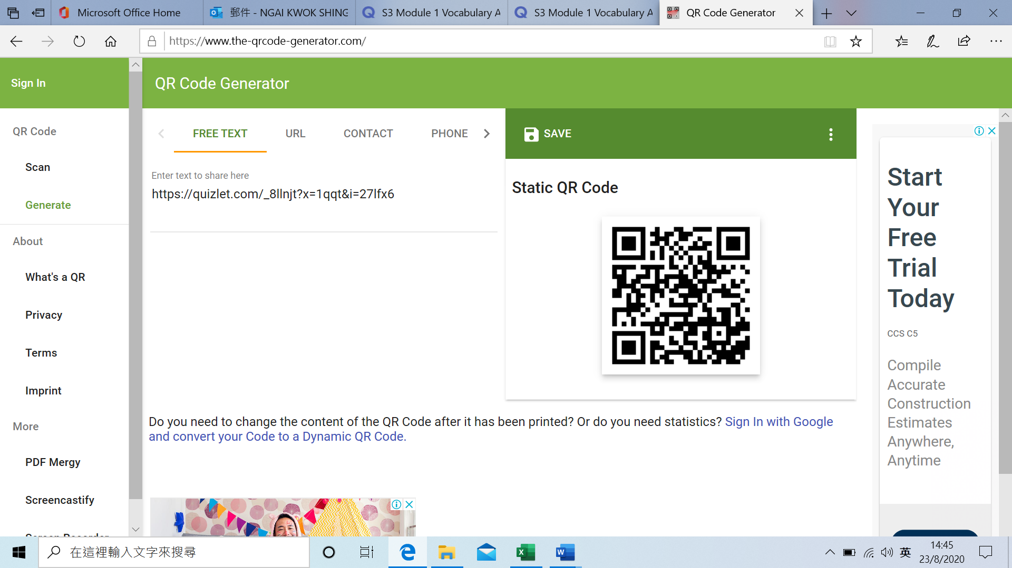

|  |  |  |  |  |
| --- | --- | --- | --- | --- |
|  |  | Line no | Part of speech | Meaning (Chinese/English/picture) |
| 1. | conventional | 2 | adj | 傳統的; 慣用的，平常的; 依照慣例的; 約定的 |
| 2. | overlooked | 3 | adj | 忽視 |
| 3. | destination(s) | 3 | noun | 目的地 |
| 4. | comprised | 4 | adj  (verb – normal usage) | 包含，包括; 由…組成; 由…構成 |
| 5. | cosmopolitan | 9 | adj | 世界性的 |
| 6. | venture(d) | 9 | verb | 冒險前進，冒險行事 |
| 7. | sight(s) | 22 | noun | 景象 |
| 8. | phenomenon | 26 | noun | 現象 |
| 9. | visible | 26 | adj | 看得見的; 明顯的，顯然的 |
| 10. | solar | 28 | adj | 太陽的，日光的; 利用太陽能的; 根據太陽決定或測定的 |
| 11. | atmosphere | 29 | noun | 大氣層 |
| 12. | entirely | 33 | adv | 完全地; 完整地; 全部地; 徹底地 |
| 13. | cruise | 38 | noun | 遊覽，旅行，周遊 |
| 14. | cuisine | 48 | adj | 烹飪，烹調法; 菜肴 |
| 15. | bound to | 49 | adj | 必將，肯定會 |
| 16. | delicacy | 51 | noun | 美味佳餚 |
| 17. | stay tuned | 55 | idiom | 敬請期待 |

**Part B: Fill in the blanks**

For questions 1-8, choose the words from numbers 1-8 of the above vocabulary list.

1. Many tourists agree that the sights of Hong Kong Wetland Park are breathtaking because of the natural environment.
2. Our class is comprised of 30 students and two class teachers.
3. Temple Street is one of the conventional attractions in Hong Kong. Many tourists go there for it.
4. Our class teacher has just shared with us a few often overlooked study tips. I think I will study better now by paying attention to these tips.
5. If you have friends or relatives overseas, make sure they put Hong Kong as one of their travel destinations by inviting them to come to our beautiful and energetic city!
6. Many people regard Hong Kong as one of the most cosmopolitan cities in the world as there are people, food, shops and companies from all over the world.
7. When I first ventured to this jungle, I was told that there were many wild animals such as tigers and lions. So I was extra careful.
8. I know that rainbow appears after the rain, but I haven’t seen this natural phenomenon for a long time.

For questions 9-17, choose the words from numbers 9-17 of the above vocabulary list.

1. Stars are visible at night. I usually gaze at the stars when I feel sad.
2. People in Hong Kong like Japanese cuisine like sushi. It is often their first choice for dinner.
3. In Hong Kong, you can easily have a try on cuisine from different countries, such as Thai, Japanese, Korean, etc. And of course, one must not forget about the mouthwatering local delicacy like egg tart, mini egg puff and so on.
4. Our school has installed solar panels on the roof. They change the sunlight into electricity.
5. Scientists have discovered a hole in the earth’s atmosphere, so we need to do something to stop its worsening in our daily life.
6. The cave is entirely dark. I cannot see anything at all.
7. If you are an ocean/ a sea lover, you may take a cruise rather than a plane when travelling next time.
8. If you would like to get extra materials for self-study, you are bound to find something useful online.
9. Stay tuned for more travelling tips at [www.travel.gov.hk](http://www.travel.gov.hk) every Sunday. You will get many useful tips there.

**Part C: Sentence making**

1. ____________________________________________________________________________________
2. ____________________________________________________________________________________
3. ____________________________________________________________________________________
4. ____________________________________________________________________________________
5. ____________________________________________________________________________________
6. ____________________________________________________________________________________
7. ____________________________________________________________________________________
8. ____________________________________________________________________________________
9. ____________________________________________________________________________________
10. ____________________________________________________________________________________

**Extra vocabulary**

1. **Travel**

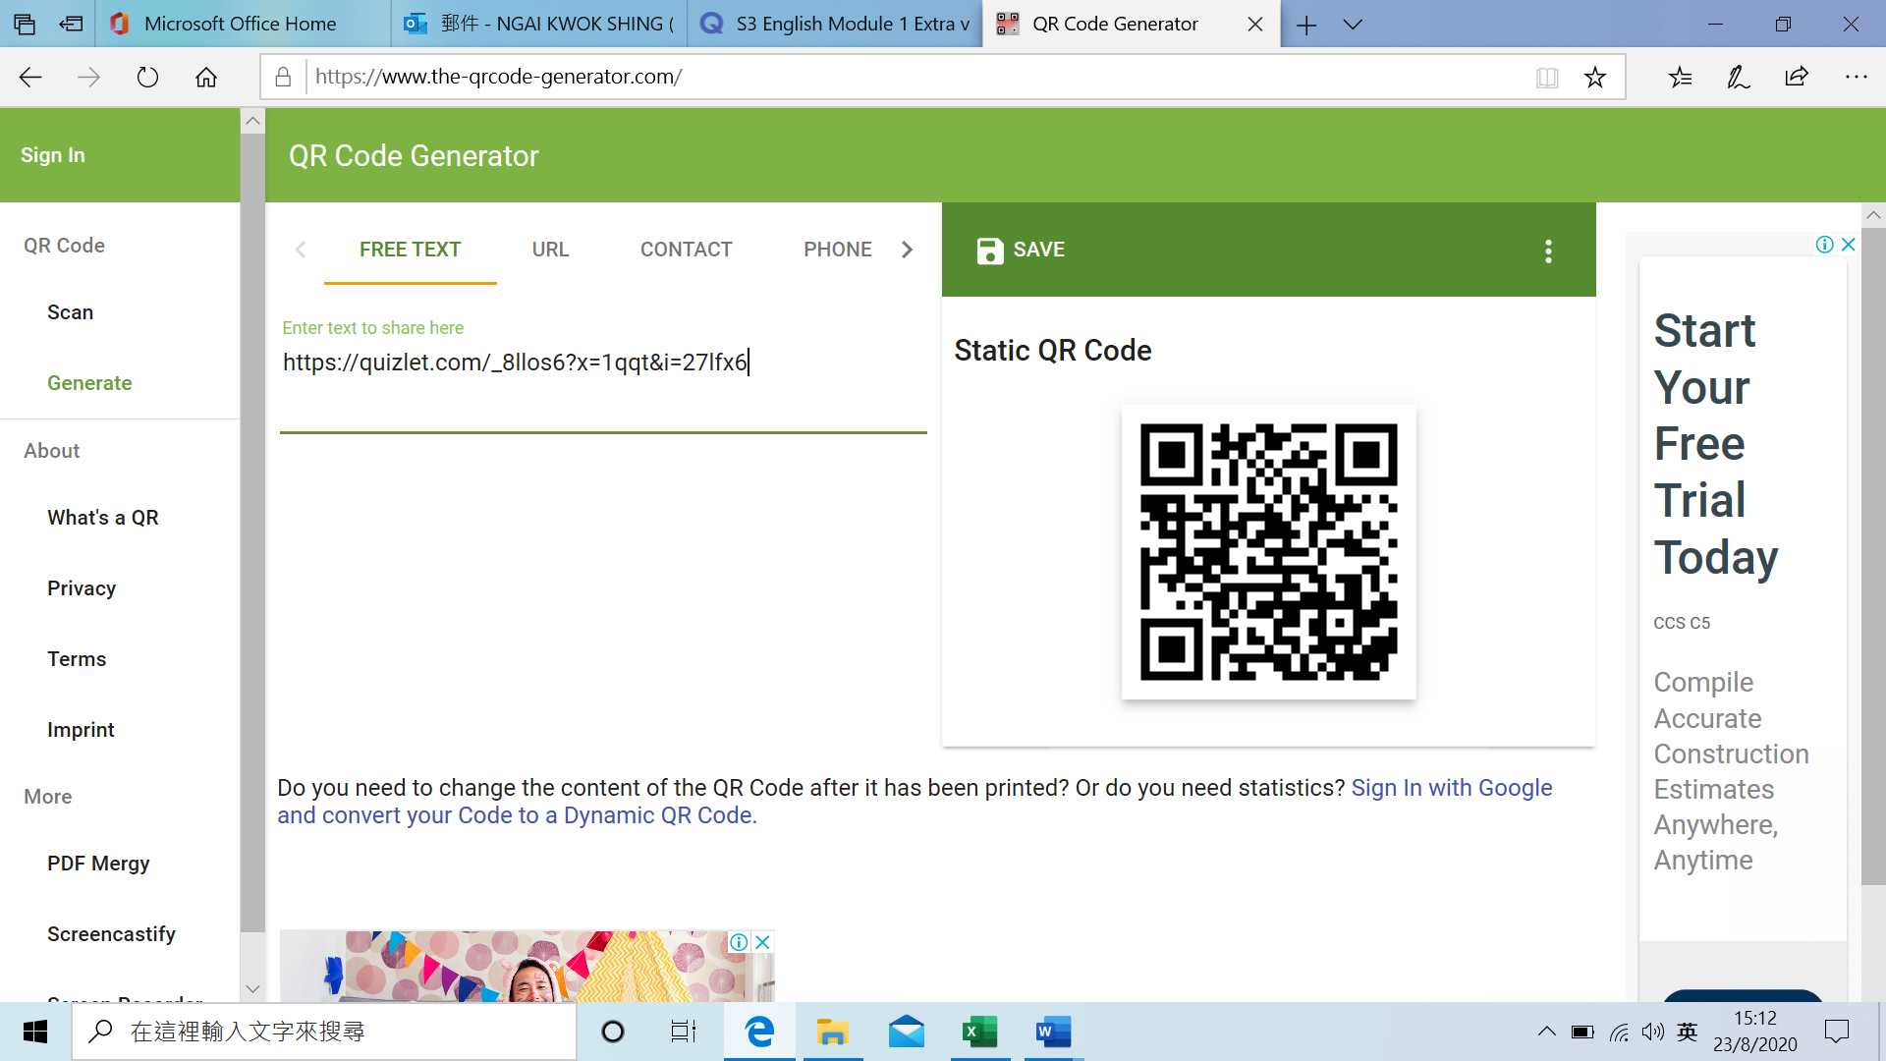

**At the airport**

|  |  |  |  |
| --- | --- | --- | --- |
|  |  | Chinese meaning | Related vocabulary |
| 1 | check in desk | （機場的）報到櫃檯 | Ground staff, scale, weight |
| 2 | boarding pass | 登機牌 | Paper, electronic |
| 3 | passport | 護照 | HKSAR, The PRC, The UK, The USA |
| 4 | luggage/ baggage | 箱包行李 | Pieces of…, carry-on bags |
| 5 | security | 安檢 | WatchGuard, police |
| 6 | customs | 海關 | Dutiable commodities, prohibited items, officers, tax |
| 7 | boarding gate | 登機口 | Gate no. |
| 8 | baggage carousel | 行李傳送帶 | Automatic, black, plastic box |
| 9 | currency exchange desk | 貨幣兌換處 | USD, RMB, Yuan, Yen |
| 10 | duty free | 免稅 | Tax, cheaper |
| 11 | lounge | 休息室 | An area, rest, eat snacks |
| 12 | transfer | 轉機 | Another country/ destination, boarding gate |
| 13 | flight attendant | 機組人員 | Cabin crew, chicken or beef, Chinese tea or coffee |
| 14 | cabin crew | 機組人員 | Flight attendant |
| 15 | restricted items | 限制物品 | Explosive materials, flammable items, poison |

**Things for travel**

|  |  |  |  |
| --- | --- | --- | --- |
|  |  | Chinese meaning | Related vocabulary |
| 16 | itinerary | 行程 | Day 1, day 2, afternoon activities |
| 17 | guidebooks | 指南 | Sightseeing spots, restaurants |
| 18 | suitcase | 行李箱 | clothes |
| 19 | backpack/ rucksack | 背包/背囊 | Daily necessities |
| 20 | toiletries | 化妝品 | Cosmetic, makeup, toothpaste |

**Other useful words**

|  |  |  |  |
| --- | --- | --- | --- |
|  |  | Chinese meaning | Related vocabulary |
| 21 | reserve | 預約 | Book, reservation, tickets |
| 22 | depart | 離開 | Leave, miss the plane |
| 23 | take off | 起飛 | fasten seat belt |
| 24 | land | 降落 | Remain seated, ready to get off the plane |
| 25 | travel agency | 旅行社 | Air tickets, travel package, special offers |
| 26 | guided tour | 導遊團 | Bilingual, languages, places of interest |
| 27 | tour guide | 導遊 | Multilingual, tour escort, give clear instructions |

**Activity 1:**

**Fill in the blanks of the following dialogue between Mrs. Lee, the tourist and Mr. Leung, the tour Manager.**

|  |
| --- |
| **A: Mrs. Lee, the tourist. B: Mr. Leung, the tour manager.**  A: Excuse me. I have never flown on an international flight. I want to make sure everything is all right.  B: Don’t worry. I’ll help you with that. First, let’s make sure you have your document ready.  A: You mean passport and ticket? Yes, here they are.  B: Right. And we are going through the check-in formalities in a few minutes.  A: Will it take long?  B: I don’t think so.  A: What should we do in the check-in counter?  B: The airport clerk will check your **passport** and ticket and then they will weigh your **baggage.** How many bags do you want to check in?  A: Just the carry-ons. I hope they are not overweight.  B: They allow twenty kilos each. I don’t think you’ve got a problem here. After the weighing, they will give you a baggage check and a **boarding pass.** But please make sure your passport and other travel documents are carried with you; don’t put them in your check-in baggage.  A: Thank you for reminder. What should I do next?  B: You need to proceed through **security** check then.  A: It seems quite complicated. When will the flight **take off**?  B: After one and half hour.  A: How can I know it?  B: It will be announced. And I’ll call you then.  A: I’m afraid it’s a long wait.  B: After the check-in, you can rest in the terminal lounge near your **boarding gate**. |

**Extra vocabulary**

1. **Holiday activities**

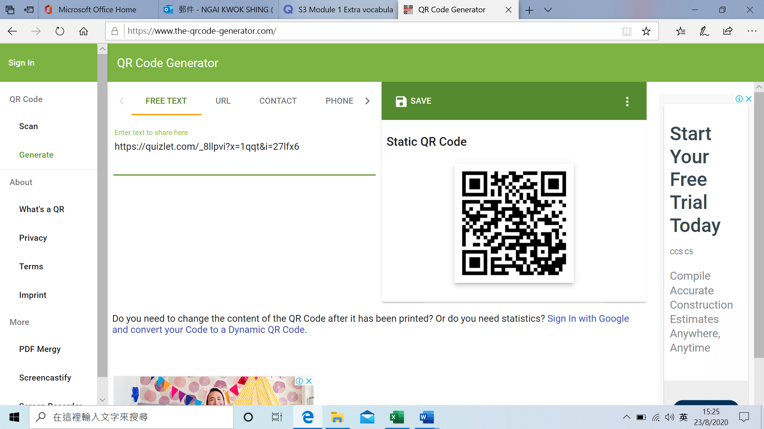

|  |  |  |  |
| --- | --- | --- | --- |
|  |  | Chinese meaning | Related vocabulary |
| 1 | kayaking | 皮划艇 | Water sports, rushing rivers |
| 2 | canoeing | 劃獨木舟 | Water sports, streams, waterways |
| 3 | trekking | 徒步旅行 | Mountain, trails |
| 4 | sailing | 航行 | Sea, canals |
| 5 | jet skiing | 噴氣式滑水車運動 | Engine, speediness |
| 6 | skiing | 滑雪 | Ice, rink |
| 7 | windsurfing | 滑浪風帆 | Sailboarding, |
| 8 | wakeboarding | 滑水 | Watersports, board |

**Adjectives for describing activities and experience**

|  |  |  |  |
| --- | --- | --- | --- |
|  |  | Chinese meaning | Related vocabulary |
| 9 | amazing | 驚人 | astonishing |
| 10 | enjoyable | 愉快的 | pleasant |
| 11 | relaxing | 放鬆 | calming |
| 12 | satisfying | 滿意的 | Adequate |
| 13 | scary | 害怕 | creepy |
| 14 | amazing | 驚人 | astounding |
| 15 | tiring | 累人 | exhausting |
| 16 | unforgettable | 難忘 | Memorable |

**Activity 2:**

**Answer the following questions in complete sentences.**

1. **Which holiday activities do you like most? Choose at least one activity and give a reason.**

______________________________________________________________________________________________________________________________________________________________________________

______________________________________________________________________________________________________________________________________________________________________________

1. **Which holiday activities do you like least? Choose at least one activity and give a reason.**

______________________________________________________________________________________________________________________________________________________________________________

______________________________________________________________________________________________________________________________________________________________________________

**Extra vocabulary**

1. **Attractions (Places to visit)**

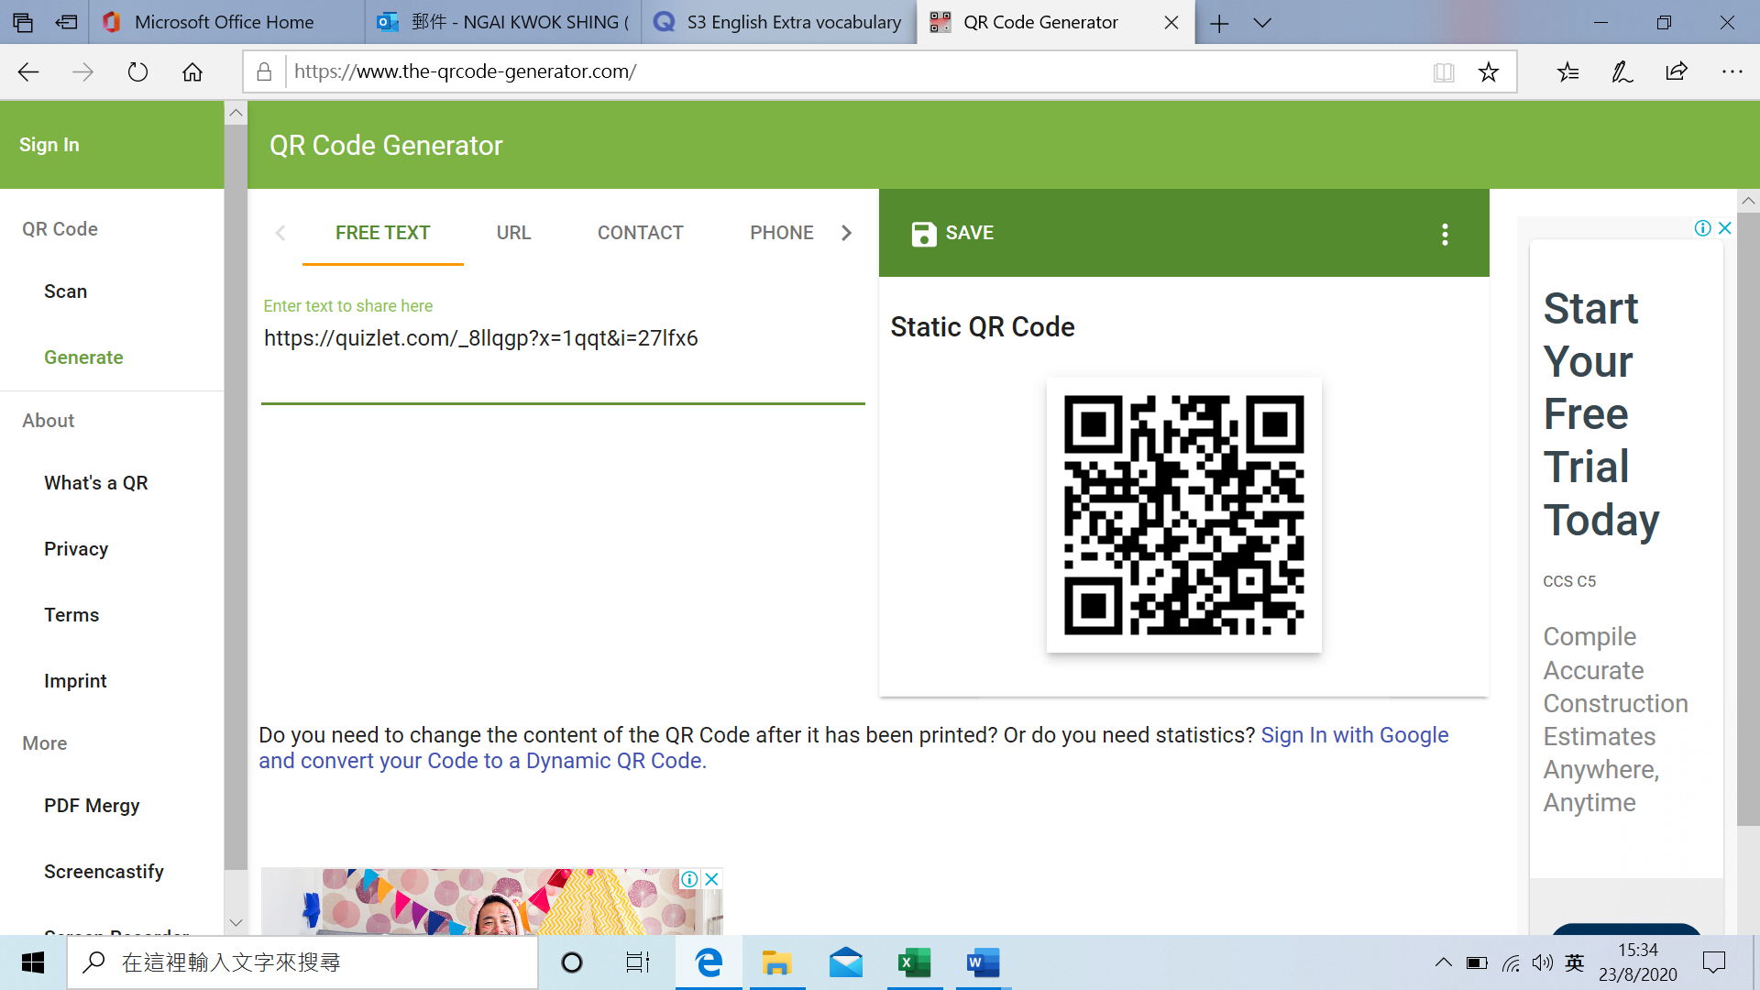

|  |  |  |  |
| --- | --- | --- | --- |
|  |  | Chinese meaning | Related vocabulary |
| 1 | amusement park | 遊樂園 | Theme parks |
| 2 | art gallery | 美術館 | Museum, display, collection |
| 3 | theatre | 劇院 | Cinema, movie, drama |
| 4 | water park | 水上樂園 | Swimming, water slides |
| 5 | aquarium | 水族館 | reptiles such as turtles |
| 6 | animal sanctuary | 動物保護區 | Spaying, neutering |
| 7 | national park | 國家公園 | conservation |
| 8 | zoo | 動物園 | Wild animals |

**Activity 3:**

**What is the best place to go in Hong Kong or mainland China?**

**Paste a photo of the place that you recommend visitors to go while they are in Hong Kong or mainland China.**

|  |
| --- |
|  |

**Describe the place that you recommended above. Write at least 50 words.**

______________________________________________________________________________________________________________________________________________________________________________

______________________________________________________________________________________________________________________________________________________________________________

**Anthology Unit 2: Worst Holiday ever!**

**Part A: Vocabulary list**

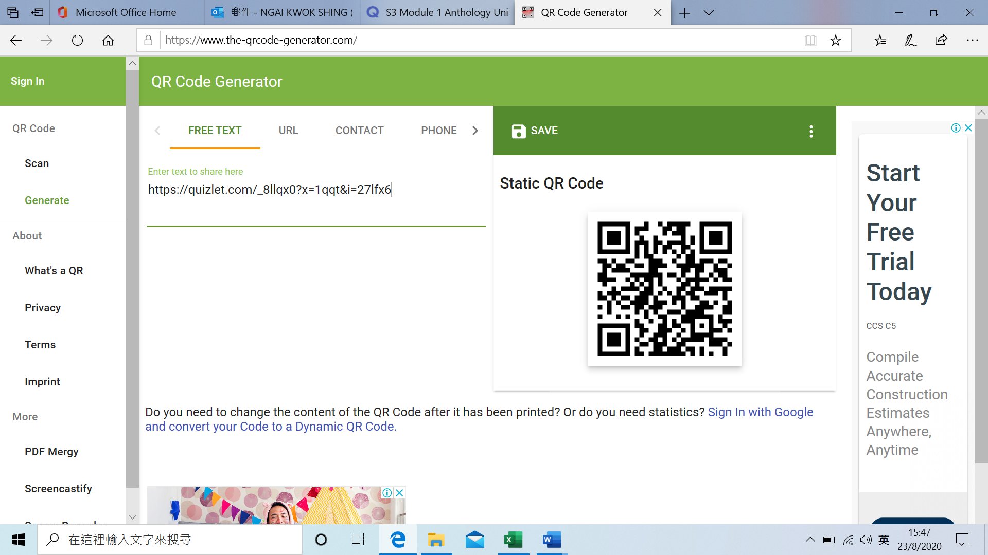

|  |  |  |  |  |
| --- | --- | --- | --- | --- |
|  |  | Line no | Part of speech | Meaning (Chinese/English/picture) |
| 1. | invaluable | 1 | adjective | 非常寶貴的; 無法估計的; 無價的 |
| 2. | soothe | 2 | verb | 安慰; 緩和; 使平靜; 減輕痛苦 |
| 3. | jet-lagged | 2 | adjective | 有時差反應的 |
| 4. | spirit | 2 | noun | 精神，心靈; 情緒 |
| 5. | lodging | 5 | noun | 出租的房間; 暫住; 寄宿; 借宿 |
| 6. | whine | 8 | verb | 哀訴，訴怨 |
| 7. | property | 11 | noun | 財產 |
| 8. | submit(ted) | 13 | verb | 提交，呈送 |
| 9. | leaky | 19 | adjective | 滲漏的 |
| 10. | dripping | 20 | noun | 滴; 滴下 |
| 11. | wardrobe | 24 | noun | 衣櫃，衣櫥 |
| 12. | chase | 28 | noun | 追逐，追趕 |
| 13. | intruder | 29 | noun | 闖入者，侵入者; 干擾者，妨礙者 |
| 14. | crush(ed) | 30 | verb | 壓破，壓碎 |
| 15. | confine(d) | 36 | verb | 限制; 局限於 |
| 16. | recurring | 47 | adjective | 再發生，復發 |
| 17. | military | 61 | adjective | 軍事的; 軍用的 |

**Part B: Fill in the blanks**

For questions 1-7, choose the words from numbers 1-7 of the above vocabulary list.

1. I usually live in budget lodging when I go travelling. Motels and hostels are my preferred choices.
2. My grandpa’s advice is invaluable. It helps me decide my future path.
3. When you travel to a place in a very different time zone from the place you are from, you might feel jet-lagged.
4. Sleeping early enables us to have a good study spirit every morning. When we do not have enough sleep, we may not have good performance in whatever we do.
5. I hate people complaining this and that all the time. If you whine again, I will leave you alone.
6. The desk that you are using is a school property. If you damage it, you will have to compensate for it.
7. These pills soothe pain effectively. I felt much better after taking them.

For questions 8-17, choose the words from numbers 8-17 of the vocabulary word list.

1. Learning isn’t confined to the classroom. For example, when you go online, you can get many useful learning resources.
2. Please submit a medical certificate to your class teacher after you have taken a day of sick leave.
3. The tap in my kitchen is always dripping. Water keeps coming out.
4. My wardrobe is too small now because I have bought many new clothes. I hope my parents will buy me a bigger one soon.
5. To run and chase each other during recess is what many kids enjoy playing in the school.
6. Many people living in high-rise buildings are afraid of insects found at home. Among all of them, a cockroach is regarded as the most unwelcoming intruder in my lifetime.
7. Whenever I see a cockroach, I use a thick book to press it down and crush it to death.
8. I don’t know why I keep seeing many cockroaches in my dream. I hate to have this recurring nightmare and I hope it won’t happen in my real life.
9. The new split air-conditioner is leaky. When I sit on the sofa, I get water on my head. Please help me call the technician to get it fixed this afternoon.
10. I like the military training camp. The marching and fighting training are interesting.

**Part C: Sentence making**

1. ___________________________________________________________________________________
2. ___________________________________________________________________________________
3. ___________________________________________________________________________________
4. ___________________________________________________________________________________
5. ___________________________________________________________________________________
6. ___________________________________________________________________________________
7. ___________________________________________________________________________________
8. ____________________________________________________________________________________
9. ____________________________________________________________________________________
10. ____________________________________________________________________________________

**Extra vocabulary**

1. **Hotels and accommodation**

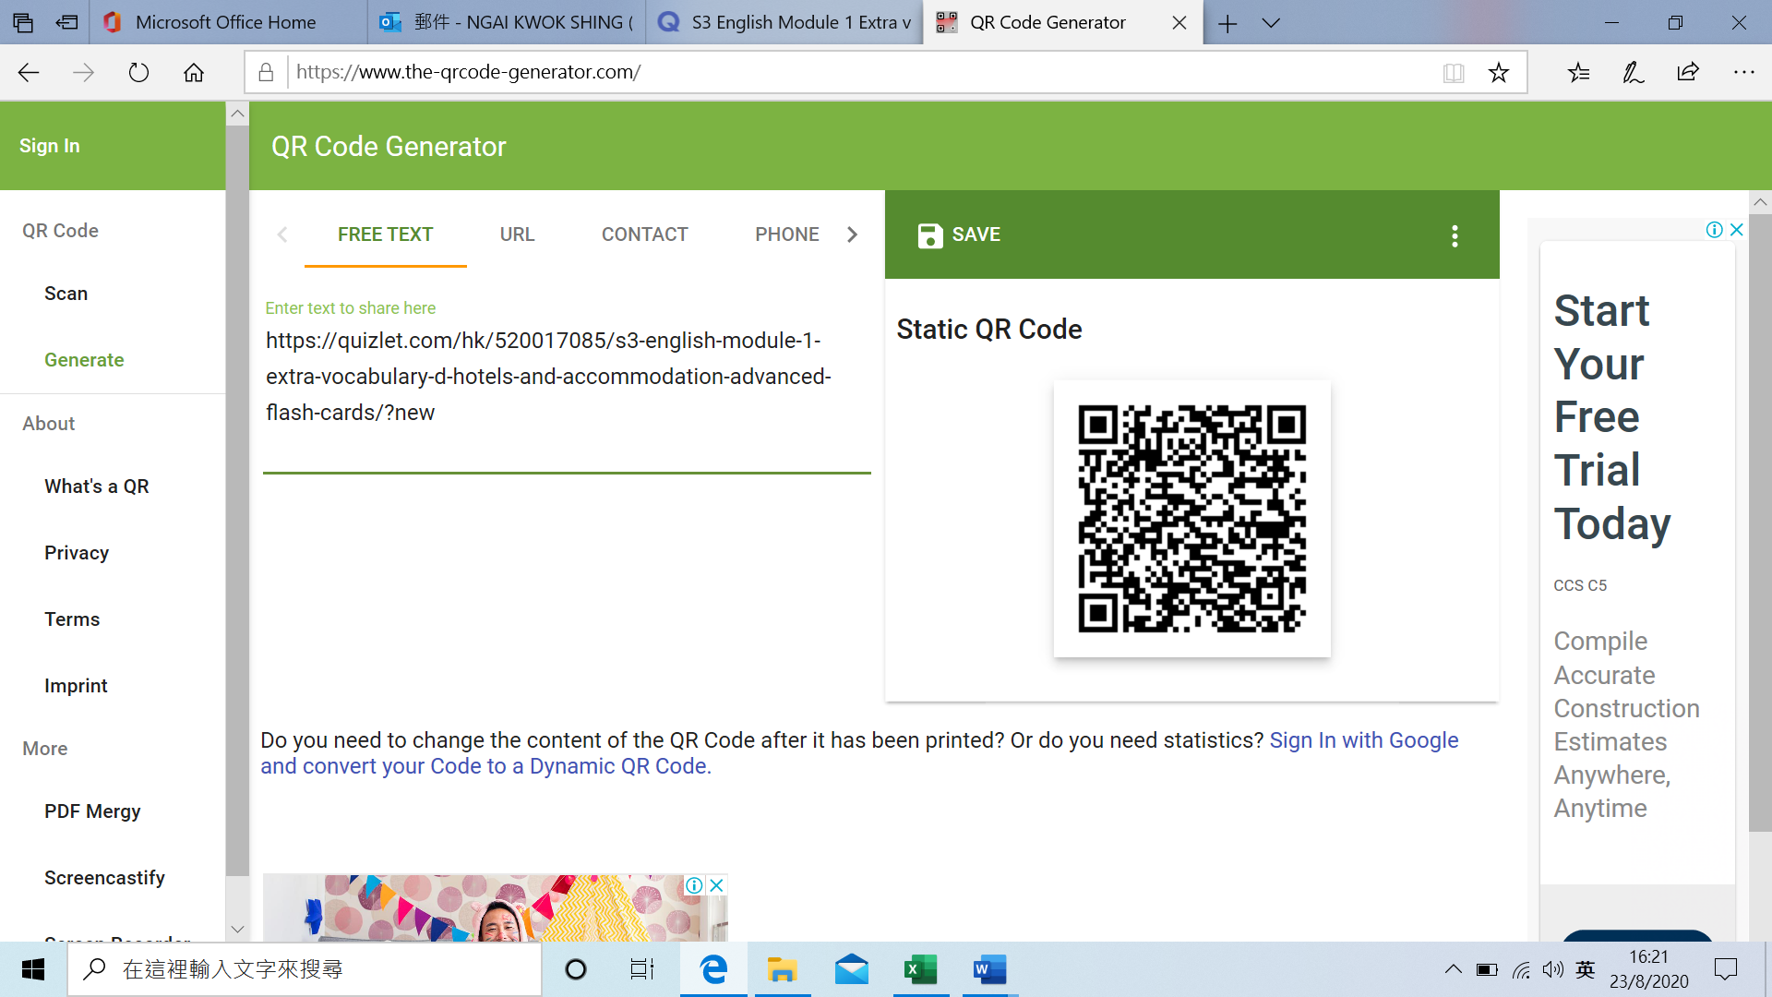

**Types of accommodation/ lodging**

|  |  |  |  |
| --- | --- | --- | --- |
|  |  | Chinese meaning | Related vocabulary |
| 1 | bed and breakfast (B&B) | 床和早餐（B＆B） | Best deals, morning calls |
| 2 | guesthouse | 招待所 | Facilities, environment, coziness |
| 3 | hostel | 旅館 | shared rooms, shared bathrooms |
| 4 | campsite | 營地 | Insects, the nature, fresh air |
| 5 | motel | 汽車旅館 | Car, vehicle, parking lots |
| 6 | mansion | 豪宅; 府邸 | Rich people, affluent |
| 7 | budget hotel | 經濟型酒店 | Cheaper prices, lower standards |
| 8 | resort hotel | 度假酒店 | Relaxation, spa, luxury |

**Types of room**

|  |  |  |  |
| --- | --- | --- | --- |
|  |  | Chinese meaning | Related vocabulary |
| 9 | single room | 單人房 | A single bed, one person |
| 10 | double room | 雙人間 | Two beds |
| 11 | twin room | 雙人房 | Two single beds |
| 12 | triple room | 三人間 | Three single beds |
| 13 | suite | 套房 | A set of rooms, armchairs, sofa |
| 14 | deluxe | 豪華房 | Grand, luxurious, comfortable furnishings |

**Hotel facilities and services**

|  |  |  |  |
| --- | --- | --- | --- |
|  |  | Chinese meaning | Related vocabulary |
| 15 | concierge | 酒店禮賓台 | Caretaker, doorkeeper, hotel employees, reservations |
| 16 | grill room | 飯店餐室 | Fine dining, beef steak, beef fillet |
| 17 | front desk | 前臺 | Book rooms, answer questions |
| 18 | housekeeping | 家政 | Keeping the rooms clean, properly equipped |
| 19 | room reservation | 預訂房間 | Booking, in advance |
| 20 | room service | 客房服務 | Food and beverage, delivery |
| 21 | security | 保安 | Safety, guards |
| 22 | laundry | 洗衣店 | Wash clothes, clothes dryers |
| 23 | conference room | 會議室 | Meeting, visualizer, projector |
| 24 | spa | 溫泉 | Mineral spring, special treatments, a health resort |
| 25 | massage | 按摩 | Squeeze, rub, relax, reduce pain |
| 26 | limousine service | 豪華轎車服務 | Car, driver, chauffeur |

**Adjectives to describe an unpleasant experience**

|  |  |  |  |
| --- | --- | --- | --- |
|  |  | Chinese meaning | Related vocabulary |
| 27 | annoying | 煩人的 | Irritating, maddening |
| 28 | awful | 令人討厭的; 可怕的 | terrible |
| 29 | disappointing | 令人失望的 | Poor, below standard |
| 30 | disgusting | 噁心的 | revolting |
| 31 | horrible | 可怕 | awful |
| 32 | irritating | 煩人的 | annoying |

**Activity 4:**

**Choose the types of lodgings and fill in the blanks**

1. A **resort hotel** may provide a golf course and swimming pool for the use of its guests.
2. The most expensive and desirable accommodations are rated **deluxe**.
3. If you enjoy a family atmosphere, you may wish to stay at a **mansion**.
4. Because it has rooms opening on a parking lot, a **motel** is very convenient for motorists.
5. Students often prefer to stay in a **hostel** because it is cheap and they can prepare their own meals.

**Activity 5:**

**Write the letter in the space provided for different needs of hotel guests**

**c** 1. Concierge a. to have meals in the guest’s hotel room.

f 2. Grill Room b. to check in at a hotel.

b 3. Front Desk c. to send the baggage down to the hotel lobby for checking out of the hotel.

**d** 4. Housekeeping

d. to have an additional set of hand towel and

blanket.

**e**  5. Room e. to reserve a twin bedroom in advance

Reservation

**a**  6. Room Service f. to dine with a high expectation of top food

quality.

**g** 7. Security g. to check strangers in the mid-night who

may annoy in-house guests.

**Extra vocabulary**

1. **Transport**

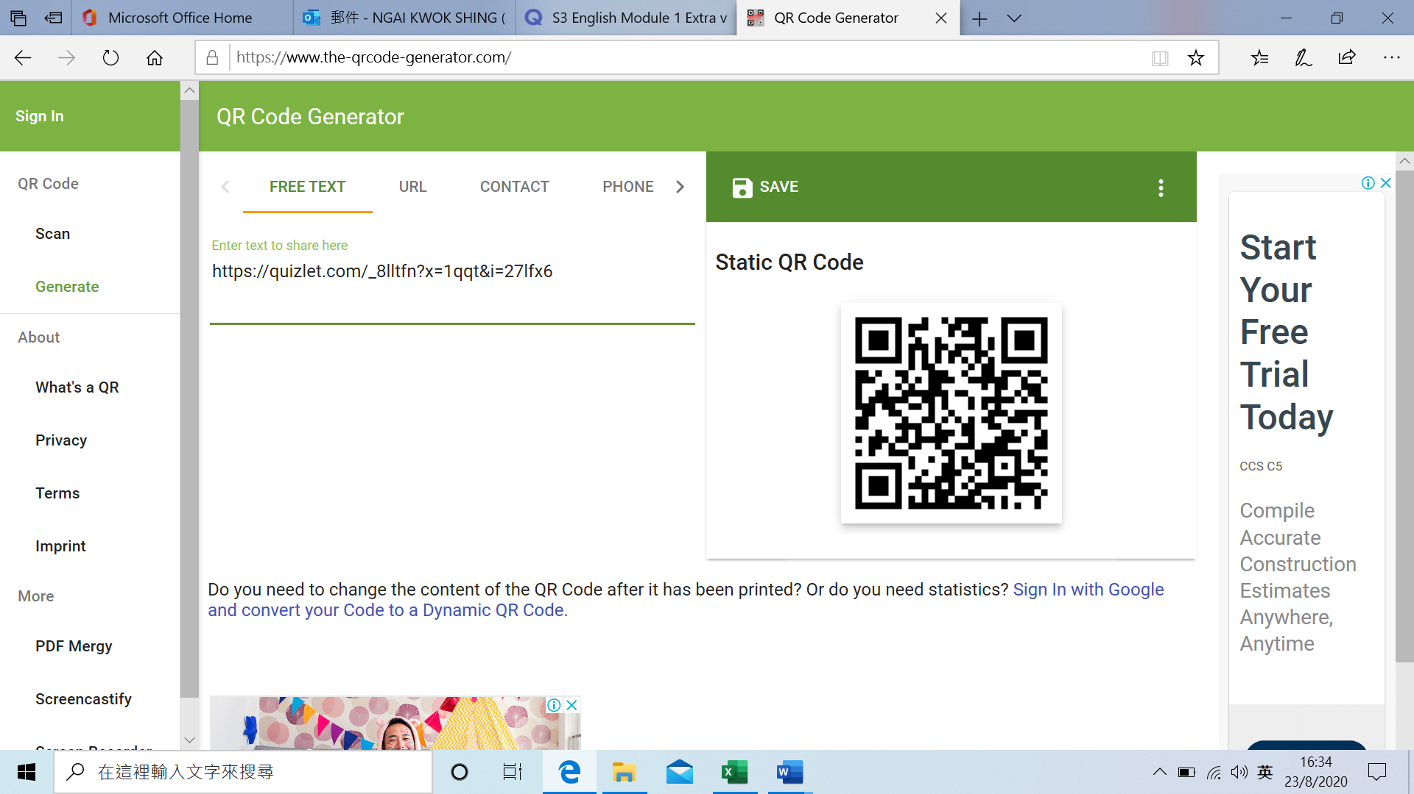

|  |  |  |  |
| --- | --- | --- | --- |
|  |  | Chinese meaning | Related vocabulary |
| 1 | coach | 長途汽車 | Bus, passengers, long journeys |
| 2 | underground/ tube/ metro/ subway | 地鐵 | Railway, octopus, add value machine |
| 3 | motorcycle/ motorbike | 摩托車 | Two wheels, engine, dangerous |
| 4 | helicopter | 直升機 | Long blades on top, move straight upwards or downwards, stay still in the air |

**Activity 6: {OPTIONAL}**

Imagine that you have a temporary job with the Transport Department. You need to interview four students (B, C, D, E) to find out what kind of transportation they use and how often. **(Student A has been done for you as an example.)** Enter their answers as data in the table on the following page (each column represents the answer of one student).

Start each interview as follows:

“Excuse me. I am collecting information for the Transport Department. I would like to ask you a few questions about transportation in Hong Kong. Would that be okay?”

Then ask these questions as a guide:

1 Do you drive your own car/motorcycle/bicycle?

2 Do you use public transport?

3 Which kind(s) – bus, ferry …

4 On average, how many times per day do you use this kind of transport?

5 On average, how many times per week …

6 On average, how much do you spend per day, per week on transport?

7 When you have finished, say ‘Thank you for your time!’

|  |  |  |  |  |  |  |  |  |  |  |  |  |  |  |  |  |  |  |  |  |  |  |  |  |  |
| --- | --- | --- | --- | --- | --- | --- | --- | --- | --- | --- | --- | --- | --- | --- | --- | --- | --- | --- | --- | --- | --- | --- | --- | --- | --- |
| Type | Tick transport used | | | | | Frequency per day | | | | | Frequency per week | | | | | Average cost per day HK$ | | | | | Average cost per week HK$ | | | | |
|  | A | B | C | D | E | A | B | C | D | E | A | B | C | D | E | A | B | C | D | E | A | B | C | D | E | |
| Private car |  |  |  |  |  |  |  |  |  |  |  |  |  |  |  |  |  |  |  |  |  |  |  |  |  | |
| Motorcycle | √ |  |  |  |  | 2 |  |  |  |  | 12 |  |  |  |  | 8 |  |  |  |  | 100 |  |  |  |  | |
| Bicycle |  |  |  |  |  |  |  |  |  |  |  |  |  |  |  |  |  |  |  |  |  |  |  |  |  | |
| City Bus |  |  |  |  |  |  |  |  |  |  |  |  |  |  |  |  |  |  |  |  |  |  |  |  |  | |
| KMB |  |  |  |  |  |  |  |  |  |  |  |  |  |  |  |  |  |  |  |  |  |  |  |  |  | |
| Red mini bus |  |  |  |  |  |  |  |  |  |  |  |  |  |  |  |  |  |  |  |  |  |  |  |  |  | |
| Green mini bus |  |  |  |  |  |  |  |  |  |  |  |  |  |  |  |  |  |  |  |  |  |  |  |  |  | |
| Taxi |  |  |  |  |  |  |  |  |  |  |  |  |  |  |  |  |  |  |  |  |  |  |  |  |  | |
| MTR |  |  |  |  |  |  |  |  |  |  |  |  |  |  |  |  |  |  |  |  |  |  |  |  |  | |
| LTR |  |  |  |  |  |  |  |  |  |  |  |  |  |  |  |  |  |  |  |  |  |  |  |  |  | |
| Ferry |  |  |  |  |  |  |  |  |  |  |  |  |  |  |  |  |  |  |  |  |  |  |  |  |  | |
| tram |  |  |  |  |  |  |  |  |  |  |  |  |  |  |  |  |  |  |  |  |  |  |  |  |  | |
| Add other transport types below |  |  |  |  |  |  |  |  |  |  |  |  |  |  |  |  |  |  |  |  |  |  |  |  |  | |
|  |  |  |  |  |  |  |  |  |  |  |  |  |  |  |  |  |  |  |  |  |  |  |  |  |  | |
|  |  |  |  |  |  |  |  |  |  |  |  |  |  |  |  |  |  |  |  |  |  |  |  |  |  | |
|  |  |  |  |  |  |  |  |  |  |  |  |  |  |  |  |  |  |  |  |  |  |  |  |  |  | |
|  |  |  |  |  |  |  |  |  |  |  |  |  |  |  |  |  |  |  |  |  |  |  |  |  |  | |
|  |  |  |  |  |  |  |  |  |  |  |  |  |  |  |  |  |  |  |  |  |  |  |  |  |  | |

**END**